AIM
To write a Python program using the NumPy library to perform arithmetic operations on arrays, scalar multiplication, square root, mean, and dot product.

ALGORITHM
- Start the program.
- Import the NumPy library using import numpy as np.
- Create two NumPy arrays, a = [1, 2, 3] and b = [4, 5, 6].
- Display both arrays.
- Perform element-wise addition using a + b and display the result.
- Perform element-wise multiplication using a * b and display the result.
- Perform scalar multiplication using a * 10 and display the result.
- Calculate the square root of each element in array a using np.sqrt(a).
- Calculate the mean of array a using np.mean(a).
- Calculate the dot product of arrays a and b using np.dot(a, b).
- Display all the results.
- Stop the program.

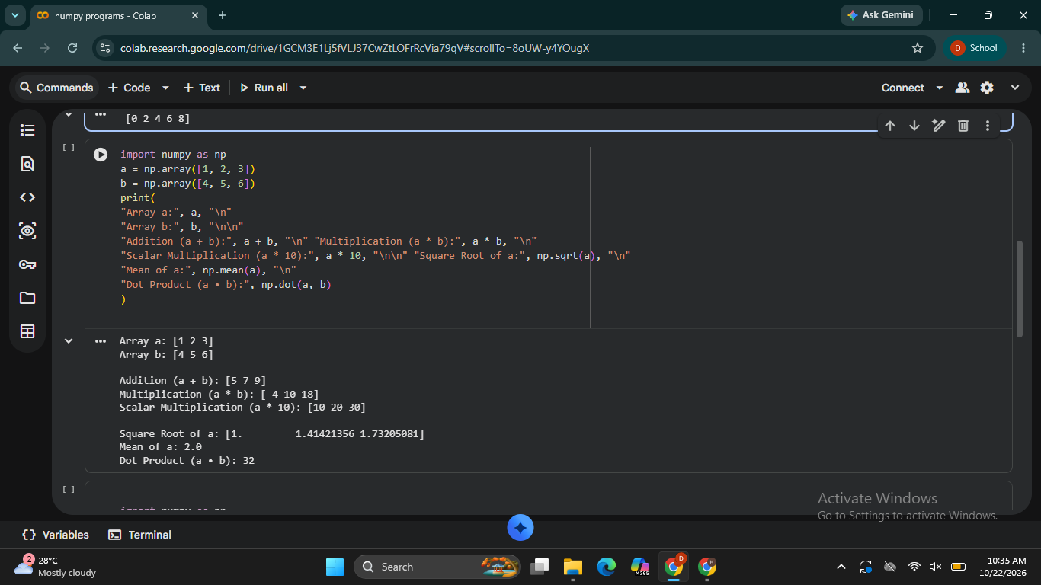

RESULT
Thus, the Python program using NumPy was executed successfully to perform array addition, element-wise multiplication, scalar multiplication, square root, mean, and dot product operations.

